
TIP: Before you proceed, identify the title of the course section (eg, BUAD 101.05) for the override request.

Some courses have eligibility requirements. If you do not meet the requirements, you must request permission from the instructor with a Pre-Requisite Override. This guide shows you how to request a pre-requisite override.

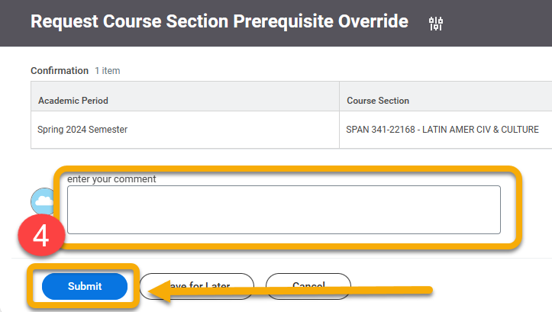
Instructions
- From your homepage, click Academics.
- Under Registration, click “Request Course Section Prerequisite Override.
- Complete the required fields in the Course Section Prerequisite Override window. Click “OK”.

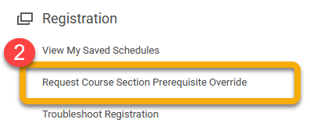

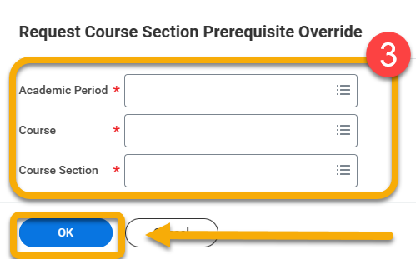
- Under comments, enter information relevant to your request for the instructor. Click “Submit”.
- Review your request. Click “Done”. This will complete the process and send your request.
- Check “Notifications” for a decision from the instructor AND Check “My Tasks” to respond to any requests for more information from the instructor.

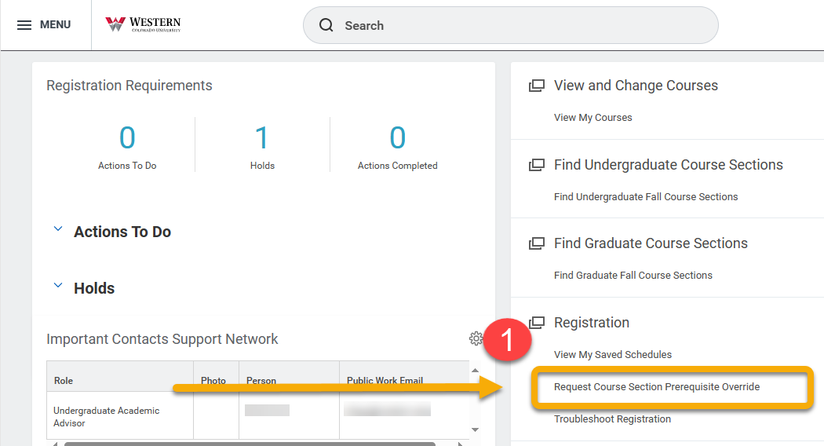
Some courses have eligibility requirements. If you do not meet the requirements, but you would still like to register for the course, you must request permission from the instructor with a Prerequisite Override. This guide shows you how to request a prerequisite override.
At the end of this guide, you will also see how your request is received and processed by the instructor.
Before you proceed, identify the title of the course section (eg, BUAD 101.05) for the override request.

Instructions
- From the Academic app, click “Request Course Section Prerequisite Override” under the Registration heading.

- The Request Course Section Prerequisite Override window will open. Complete the three required fields.

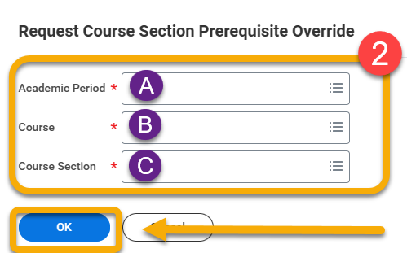

- Click the field and follow the prompt, selecting the Current Period and then the period in which you wish to register.

- Click the field and type the first part of the course code, usually 3-4 letters and a three digit code (eg, ACC 101). If you do not have this information, return to the Academics app and click “Find Undergraduate/Graduate Course Section”.

If your desired course does not display in the field, then it does not require permission.

- Type the section code for the course section. If there is only one section available, it will auto-populate.

TIP: If you do not prefer any particular section, but are willing to enter any available, you must complete the form for each course section.

- Click “OK”
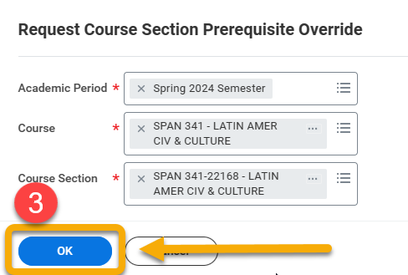

- Review the course information. Comments are strongly encouraged. These will go directly to the instructor making the override decision. For example, if you already spoke to the instructor about overriding the pre-requisite, consider mentioning this conversation.

To send it to the instructor, click “Submit”.

If you are not sure, click “Save for Later”. This sends your request draft to the “My Tasks” folder in the top right-hand corner of your screen to review at a later time.
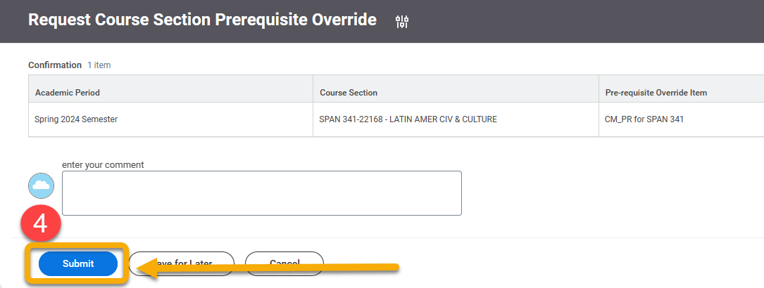

- Next, you will see a page confirming your request. The information on this page will go to the instructor making the override decision.

Review the information for accuracy and click “Done”.

To see what your request looks like on the instructor’s view, skip to the end of this guide.
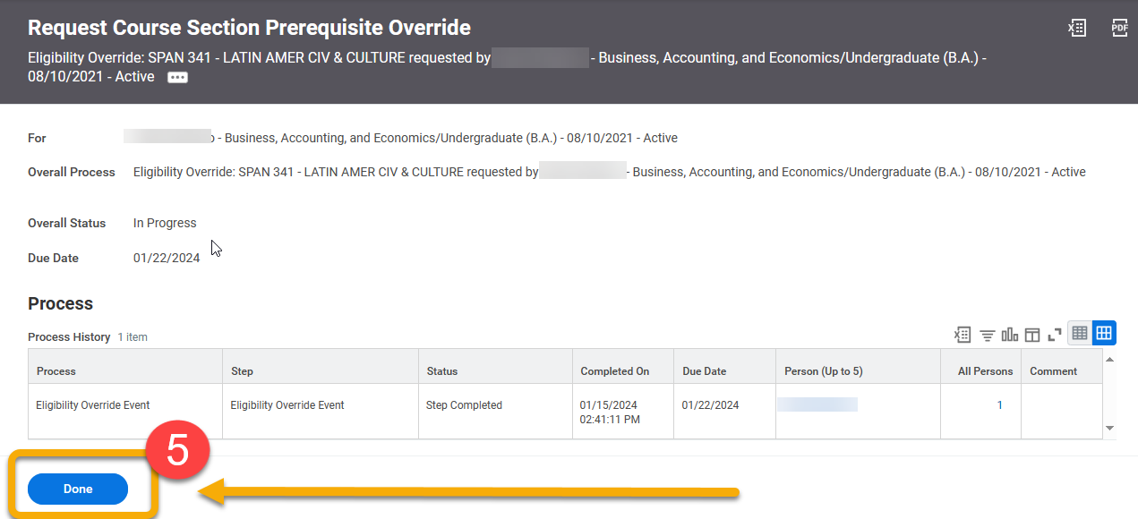
- When the instructor receives your request, they have the option to APPROVE, DENY, or SEND BACK for more information.

If the instructor decides to APPROVE or DENY, you will be notified in “Notifications”. To view, click the “Notifications” bell in the upper right-hand corner.


In this example, the request is approved.
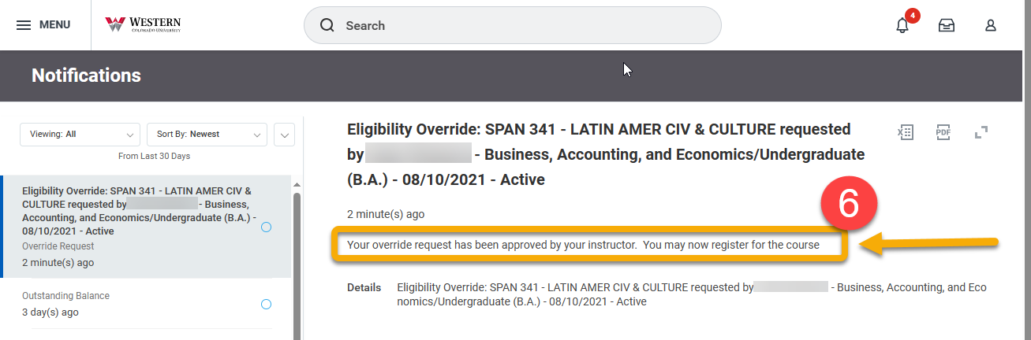

In contrast, if the instructor requests more information, you will receive a message in “My Tasks”.


 If you have requested an override, closely monitor My Tasks and Notifications
- To view the instructor’s response, click “My Tasks”. Carefully read the instructor’s inquiry. Enter a reply in the comment box.

Click “Submit”.

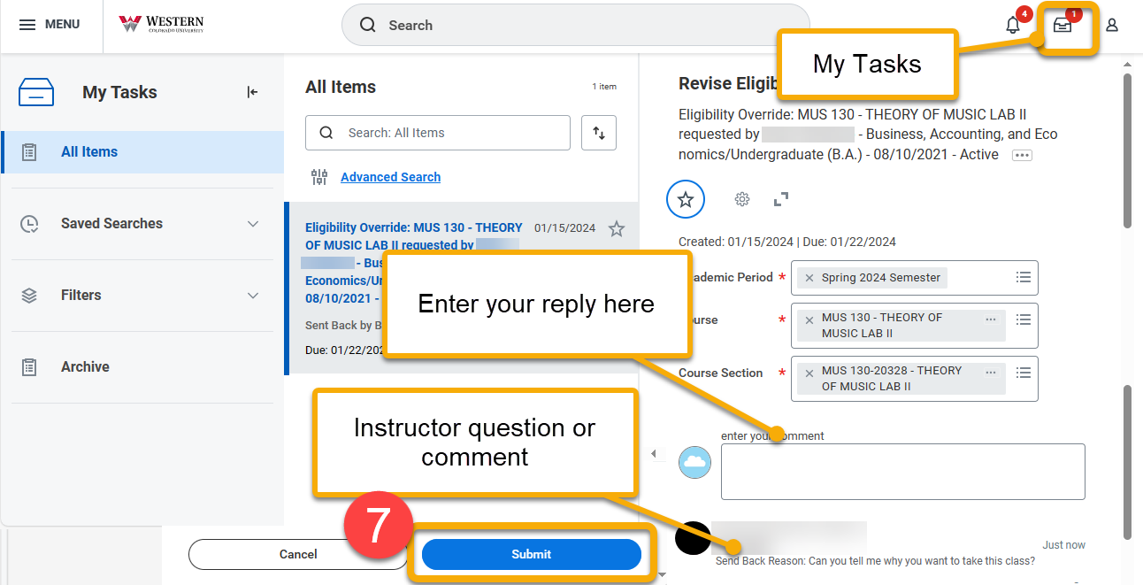
The instructor will be immediately notified of your response and prompted to make an APPROVE or DENY decision. You will receive the instructor’s decision under “Notifications”.

- Upon receiving the prerequisite override, you are NOT automatically registered for the course section. Return to Find Undergraduate/Graduate Course Sections to locate and register for this particular course. Or, if registration is not yet open, save the course section to a saved schedule.

Instructor View
For your information, this guide will show you how the instructor receives and processes your prerequisite override.

- The instructor will be notified of your request in “My Tasks”.


- Upon opening “My Tasks”, the instructor will see the same details in your request confirmation, including your name, major, and any comments.

The instructor is prompted to click “APPROVE” or “DENY”.

If the instructor needs more information, they may add comments and send it back to you. You will receive these comments or questions in “My Tasks”.

